Data Transfer Specifications

***Study No.:***

***Protocol No.:***

***Version Number:***

***Version Date:***

**Contents**

**1.** **Document Control and History** 4

**2.** **Document Purpose** 4

**3.** **File Specification** 4

**3.1.** **General Requirements** 4

**3.2. Transfer Frequency** 5

**3.3. File Type** 5

**3.4. File Nomenclature** 5

**4. Data Specification Table** 6

**5. Method of Transfer:** 7

**5.1. For Data exports from Luxembourg Institute of Health:** 7

**5.2. For Data imports to Luxembourg Institute of Health:** 8

**6. Contacts :** 8

**7. Authorization** 9

GENERAL INSTRUCTIONS. ***PLEASE DELETE THESE GENERAL INSTRUCTIONS BEFORE SENDING FOR REVIEW/FINALISING:***

* This is a template for data transfer specifications, which may be considered as a complete document.
* However, some sections would be customized per study.
* Only the text in blue italics can be updated/ may be deleted per study.
* Please do not delete, rearrange any sections.
* If a given section is not applicable for your study, please delete the text below the section header and mention “Not Applicable”

# **Document Control and History**

|  |  |  |  |
| --- | --- | --- | --- |
| **Revision** | **Date** | **Author** | **Summary of Changes** |
| *For Example: 1.0* | *1-Jan-2022* | *Priyanka Mendon*  *Clinical Data Manager, Luxembourg Institute of Health* | *Initial Version* |
|  |  |  |  |
|  |  |  |  |

# **Document Purpose**

This document defines the technical specifications for the *<mention type of transfer, e.g., clinical lab data file format>*. This format is defined by *<mention initiator of the document; e.g. Luxembourg Institute of Health>* for the purpose of data transfers.

This document provides all the details and requirements for the *<mention type of transfer, e.g., clinical lab data file format>* and transfer. All requirements defined in this document apply, unless otherwise discussed and agreed upon between *<mention stakeholders for data transfer; e.g. Luxembourg Institute of Health and Sponsor/University Name>*.

Any changes to the Data Transfer Specifications shall be recorded on this document under Section **1. Document Control and History**.

# **File Specification**

## **General Requirements**

* All subject data generated by the *<mention type of data, e.g., clinical lab data>* will be included in data transfers.
* The first row (header) of the file shall contain the item names as specified under Section 4 of this document. The transfer will be via secure data transfer to *<mention stakeholders for data transfer; e.g. Sponsor/University Name>* as described in Section 5 of this document.

## **3.2. Transfer Frequency**

* The data file(s) shall be transferred as listed below:
* With each transfer, *<Delete which is not applicable; only the data applicable to the specific period (selective) or entire data (cumulative)>* will be transferred.
* Frequency of transfer would be as below:

Test Transfer: Before study Go-Live

*<First Transfer: After Screening*

*Second Transfer: After 3 months of first subject first visit.*

*Interim Transfer: After every 6 months from first subject first visit.*

Final Transfer: Prior to database lock.

*Ad-hoc transfers: Per request>*

## **3.3. File Type**

*<Please check which is applicable>*

Excel file (.xls, .xlx)

Comma Separated Values (.csv)

Text file (.txt)

Other file format, please specify: __________________________

## **3.4. File Nomenclature**

* File names must be in all lower case without spaces.
* File names shall follow the naming convention: ***{study name or protocol number}_{date of file creation in ddmmmyyyy}_{unique identifier, if applicable}.File type***
* Unique identifier: If more than one file is created on the same date, the sequence number of each file must be used as an identifier to create a unique file name. The identifier may be omitted if only one file is created on the same date.
* *Example: ABC123_18Mar2020_01.csv*

# **Data Specification Table**

* The following tables describe the variables associated with each data file record.
* The values in the “Col. Name” column would be used as header names in the data file.
* *If all the variables of the study would be required for data transfer, the codebook document in pdf format shall be attached.*
* *For every update to the codebook, a new pdf should be attached and this specification up versioned.*

|  |  |  |  |  |
| --- | --- | --- | --- | --- |
| **Column #** | **Column/Variable Name** | **Field Format** | **Expected Values** | **Comment** |
| *1* | *Study ID* | *Alphanumeric* | *ABC/123* | *Protocol number.* |
| *2* | *Subject ID* | *Alphanumeric* | *ABC/123* | *First three digits = subject screening number and last three digits = randomized number (e.g.: Screening = 001/N/A). Numbering starts at 001.* |
| *3* | *Visit Name* | *Text* | *Screening visit, Visit 1, Treatment* |  |
| *4* | *Test Name* | *Text* | *Blood Glucose* |  |
| *5* | *Test Code* | *Text* | *GLU* |  |
| *6* | *Unit* | *Text* | *mg/dL* |  |
| *7* | *Test Result* | *Numeric* | *110* |  |

# **5. Method of Transfer:**

## **5.1. For Data exports from and data imports to Luxembourg Institute of Health:**

* The data transfer would be via secure medium, **LIH File Sender**
* **For Sending files from LIH to external partner:**

LIH clinical data manager *<mention name and email address>* will send the export file via LIH File Sender to *<mention name and email address of external recipient/s>*

* LIH data manager uploads the file on the File Sender application, specifying the date of expiry, and number of rows and columns to be confirmed by a recipient.
* Recipient/s receives a voucher in email with a download link to contents of the file
* This voucher has an expiry date; hence, the file contents should be downloaded within the date of expiry.
* Recipient downloads the file and confirms to LIH clinical data manager that file is received with no errors or if there are any issues.
* If no issues, recipient sends an email confirmation of number of rows and columns in the download.
* LIH clinical data manager maintains *Study data transfers INPUT-OUTPUT log template* with above information.

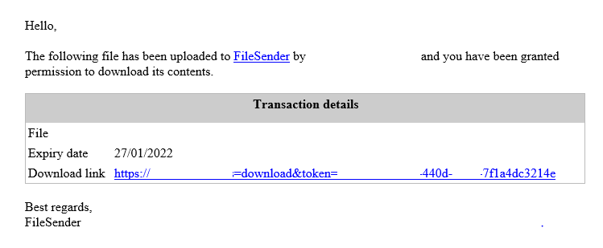

*Screenshot of the voucher received by recipient in email*

* **For Sending files from external partner to LIH:**
* LIH clinical data manager sends a voucher to the partner using LIH File Sender
* Recipient uploads a file using the voucher; specify the date of expiry and number of rows and columns.
* LIH clinical data manager receives an email confirming a file upload to the link
* LIH clinical data manager downloads the file contents, and confirms (or not) good reception of number rows and columns.
* LIH clinical data manager maintains *Study data transfers INPUT-OUTPUT log template* with above information.

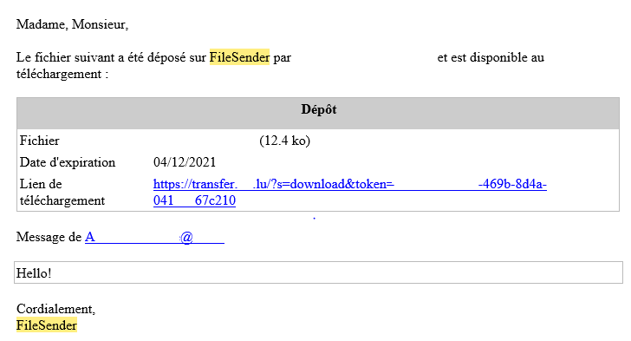

*Screenshot of the confirmation received by LIH in email*

## **5.2. For Data imports to Luxembourg Institute of Health (When using external partner’s file transmit tool)**

*Describe the process followed by the external partner to send the files to Luxembourg Institute of Health.* ***Delete the description and type “NA” if section is not applicable***

* The data transfer would be via secure medium, *<File transfer app name>*
* *<External stakeholder name>,* uploads the file on the *<File transfer app name>*
* *<External stakeholder name>, e.g, Sponsor/University Name>* sends the export file via *<File sender app name> to* *<mention name and email address of LIH data manager and back up >*
* *Describe the process of receipt of files by LIH data manager*

# **6. Contacts :**

**Luxembourg Institute of Health:**

Queries regarding the electronic data should be directed at the following Luxembourg Institute of Health Staff

Primary Contact:

Name: ______________________________

Email: _______________________________

Tel (office): _____________________________

If Primary Contact is not available:

Contact Name: ______________________________

Email: __________________________

Tel (Office): ____________________________

**<External Stakeholder Name>:**

Queries regarding the electronic data should be directed at the following <*External Stakeholder Name>* Staff

**Primary Contact:**

Name: ______________________________

Email: _______________________________

Tel (office): _____________________________

**If Primary Contact is not available:**

Contact Name: ______________________________

Email: __________________________

Tel (Office): ____________________________

# **7. Authorization**

Both parties hereby acknowledge this Data File Specification and agree to all the specifications specified therein.

_____________________________________________________________________________

**Signature & Date:**

Name and Designation*, <External Stakeholder>*

______________________________________________________________________

**Signature & Date:**

Name and Designation, *<LIH Clinical Data Manager>*